National Trends in Surgery for Sinonasal Malignancy and the Effect of Hospital Volume on Short Term Outcomes

David Ouyang1, Ivan El-Sayed2, Sue S. Yom12

Institutions: 1. Department of Radiation Oncology, University of California, San Francisco, San Francisco, CA, United States, 2. Department of Otolaryngology, University of California, San Francisco, San Francisco, CA, United States

Corresponding Author:   
Sue S. Yom, MD, PhD  
Department of Radiation Oncology

Helen Diller Family Comprehensive Cancer Center

University of California, San Francisco

1600 Divisadero St. Suite H-1031

San Francisco, CA 94143   
[415-353-9893](tel:415-353-9893)  
[yoms@radonc.ucsf.edu](mailto:yoms@radonc.ucsf.edu)

Keywords: Paranasal Cancer, Sinonasal Surgery, National Inpatient Sample  
Running Title: Trends in Sinonasal Cancer Surgery

Tables: 4

Figures: 1  
  
Word Count:

**Abstract**

Objective/Hypothesis: Sinonasal carcinomas are a collection of highly morbid neoplasms originating from the nasopharynx and paranasal sinuses. Over the last two decades, combinations of surgery, radiation, and chemotherapy have been used to treat sinonasal malignancies. We sought to characterize the trends in initial management of sinonasal malignancy and the impact of hospital volume on surgical care and outcomes.

Methods: We performed a retrospective cohort study with time trends of patients admitted for surgical resection of sinonasal malignancy in the National Inpatient Sample (NIS) between 1988 and 2009. Subset analysis was performed on patient cohorts with skull base involvement, orbital or maxillary sinus involvement, or requirement for radical neck dissection. Patient characteristics as well as hospital attributes were correlated with patient morbidity and mortality.

Results: Over the course of 22 years, we identified 3850 cases of sinonasal surgery patients from 879 hospitals. 14.9% of patients had complications and 0.8% of hospitalizations resulted in mortality. Older age was associated with higher morbidity and mortality. Cardiopulmonary complications, including pulmonary collapse and myocardial infarction, and infectious causes, most commonly urinary tract infection and surgical site infection, accounted for 13.5% and 34.6%, respectively, of all complications.

Cases including neck dissection, orbital or maxillary sinus involvement, or skull base involvement were associated with higher rates of morbidity and mortality. 24.4% of these high-risk surgeries were associated with complications, compared to 11.3% of cases without extra-sinonasal involvement. We identified 32 hospitals that averaged more than 5 cases per year and accounted for 28% (1097) of all sinonasal surgeries. These hospitals were likewise overrepresented in high risk cases – accounting for 32.4% of cases requiring neck dissection, 44.9% of cases with orbital involvement, and 45.7% of cases with skull base involvement.

Conclusions: This study reflects changing trends in the primary management of sinonasal cancer, with a increased likelihood for initial surgery at higher-volume hospitals. Complicated cases resulted in higher rates of complications but were not associated with higher mortality. Higher complication rates were seen at higher volume hospitals, but this finding was associated with an overrepresentation in the management of complex cases.

**Introduction**

Sinonasal carcinomas are a collection of highly morbid neoplasms originating from the nasopharynx and paranasal sinuses. These cancers are typically of epithelial cell origin, with the majority being squamous cell carcinomas, although a wide range of tumors can originate from the sinonasal cavities. Sinonasal carcinomas are typically initially asymptomatic, but local invasion can result in a constellation of symptoms including chronic nasal discharge, epistaxis, congestion, anosmia, neuropathies, edema, and visual disturbances. It is relatively uncommon for sinonasal cancers to present with lymph node or distant metastases, but they do frequently present with anatomically advanced disease due to proximity to the orbits and skull base.

Sinonasal cancers are uncommon – accounting for only between 1 – 3% of head and neck cancers [1,2]. Given the low incidence and heterogenous histology of sinonasal cancers, there are no randomized trials indicating the optimal management. Primary treatment of sinonasal cancers can include a program of radiotherapy with or without chemotherapy or may be treated with initial surgical resection and postoperative radiotherapy with or without chemotherapy. Although there is a high incidence of local recurrence, there is insufficient high-level evidence to suggest the superiority of either approach.

A few institutions have published their experiences with sinonasal cancers [1,3,4,5,6,7], but these institutional case series each have fewer than 75 patients and represent different perspectives in treatment era and overall approach to sinonasal cancers. An early case series from the University of Florida reviews the experience with a primarily radiotherapy-only approach, with 52% 5-year actuarial survival [3], while a more recent case series from the M.D. Anderson Cancer Center with more inclusion of surgery and post-operative radiotherapy achieved 82% 5-year survival. Case studies have suggested a rate of local recurrence of 28-41% and 5-year actuarial survival rates of 40-82%.

Given the limited individual institutional experiences with sinonasal cancer and the incomplete understanding of surgery in initial management, we sought to examine contemporary patterns of sinonasal cancer surgery. In this study, through analysis of a national inpatient database, we investigate the surgical outcomes of patients who underwent sinonasal cancer surgery and evaluate the impact of hospital volume on short-term outcomes.

**Materials and Methods**

**Data Source**

A retrospective cross-sectional analysis of patients who underwent surgical resection of primary cancer of nasal cavities and paranasal sinuses was performed using data from the National Inpatient Sample (NIS) from the Healthcare Cost and Utilization Project, Agency for Healthcare Research and Quality. The NIS is the largest database of all-payer inpatient discharge information, sampling approximately 20% of all non-federal US hospitals and including approximately 9 million hospital admissions each year. Each NIS entry includes all diagnosis and procedure codes of activity during the patient’s hospitalization at the time of discharge as well as patient demographics, hospital characteristics, and short-term complications of the hospitalization.

**Data Extraction**

All available data from 1988 through 2009 were queried. Patients admitted for primary head and neck cancer with a primary procedure of surgical resection in the maxillary, frontal, ethmoid, or sphenoid sinuses were identified. Higher-risk surgeries were identified by orbital or skull base involvement as well as surgeries requiring neck dissection. Incidences of in-hospital mortality as well perioperative morbidity such as post-operative infections, cardiopulmonary complications, hemorrhagic complications, nerve palsies, and deep vein thrombosis were identified.

**Statistical Analysis**

The total number of hospitalizations was plotted annually from 1988 to 2009 and hospital volume was also assessed for each hospital in the database. Hospital-level data was stratified by hospital caseload to compare complication rates between high- and low-volume hospitals. The Pearson chi-square test was used to analyze differences in low-volume and high-volume hospitals as well as differences in complication rates. Logistic regression models were used to assess the influence of patient demographics and hospital characteristics on complication rates. All analyses were performed using Python 2.7 (Python Software Foundation, www.python.org) and R 2.13 (R Foundation, www.r-project.org).

**Results**

We identified 3850 cases of sinonasal surgery between 1988 and 2009 (Figure 1). Patients had a mean age of 61 years old and stayed on average 6.8 days in the hospital. Consistent with previous accounts, we found a male predominance, comprising 57.2% of all patients. Aggregate patient race, sex, age, and insurance status did not vary between high and low volume centers (Table 1), and the overall demographics have not changed over time (Supplemental Figure A, B, C). The volume of sinonasal cancer surgery has not changed appreciably over the last twenty years, but a greater proportion of these surgeries are now being performed at higher-volume centers (Figure 1, R2 = 0.268, p > 0.001).

|  |  |  |  |  |  |  |  |  |  |  |  |
| --- | --- | --- | --- | --- | --- | --- | --- | --- | --- | --- | --- |
| **Table 1.** Patient Demographics for Sinonasal Cancer Surgery | | | | | | | | | | | |
|  |  | | **High Volume Centers  (>5 Cases/Year)** | | | | **Low Volume Centers (>5 Cases/Year)** | | | |  |
| Age, mean (SD) | | | 59.8 ± 14.3 | | | | 62.0 ± 17.2 | | | |  |
|  |  | |  | |  | | | |  | | |
| Sex, n (%) | Female | | 424 (40.0) | | | | | 1214 (43.5) | | |  |
|  | Male | | 633 (60.0) | | | | | 1568 (56.2) | | |  |
|  |  |  | |  | | | |  | |  | |
| Race, n (%) | White | | 632 (59.6) | | | | | 1424 (51.1) | | |  |
|  | Black | | 53 (5.0) | | | | | 214 (7.7) | | |  |
|  | Hispanic | | 54 (5.1) | | | | | 163 (5.8) | | |  |
|  | Asian/Pacific Islander | | 30 (2.8) | | | | | 65 (2.3) | | |  |
|  | Native American | | 1 (0.1) | | | | | 9 (0.0) | | |  |
|  | Other or unknown | | 271 (26.0) | | | | | 879 (31.5) | | |  |
|  |  | |  | |  | | | |  | | |  |
| Primary payer, n (%) | Private | | 440 (41.5) | | | | | 1288 (46.2) | | |  |
| Medicaid | | 69 (6.5) | | | | | 214 (7.7) | | |  |
|  | Medicare | | 480 (45.2) | | | | | 1066 (38.2) | | |  |
|  | Self-pay | | 40 (3.8) | | | | | 75 (2.7) | | |  |
|  | Other or unknown | | 27 (2.5) | | | | | 110 (3.9) | | |  |
|  |  | |  | |  | | | |  | | |  |
| **Total, n (%)** |  | | **1061(28.5)** | | | **2789 (71.5)** | | | | |  |

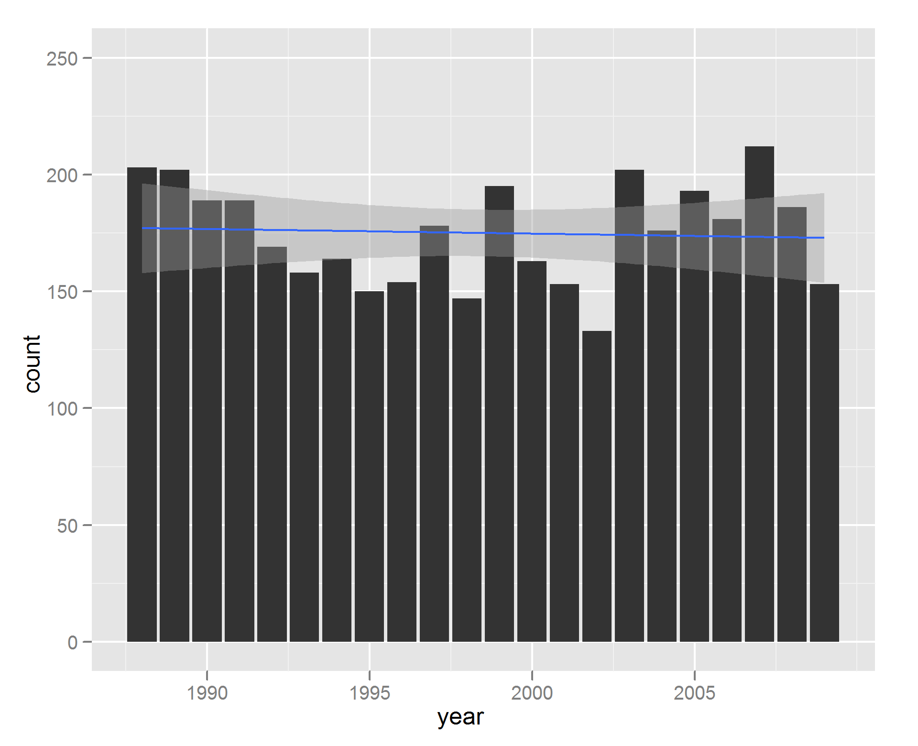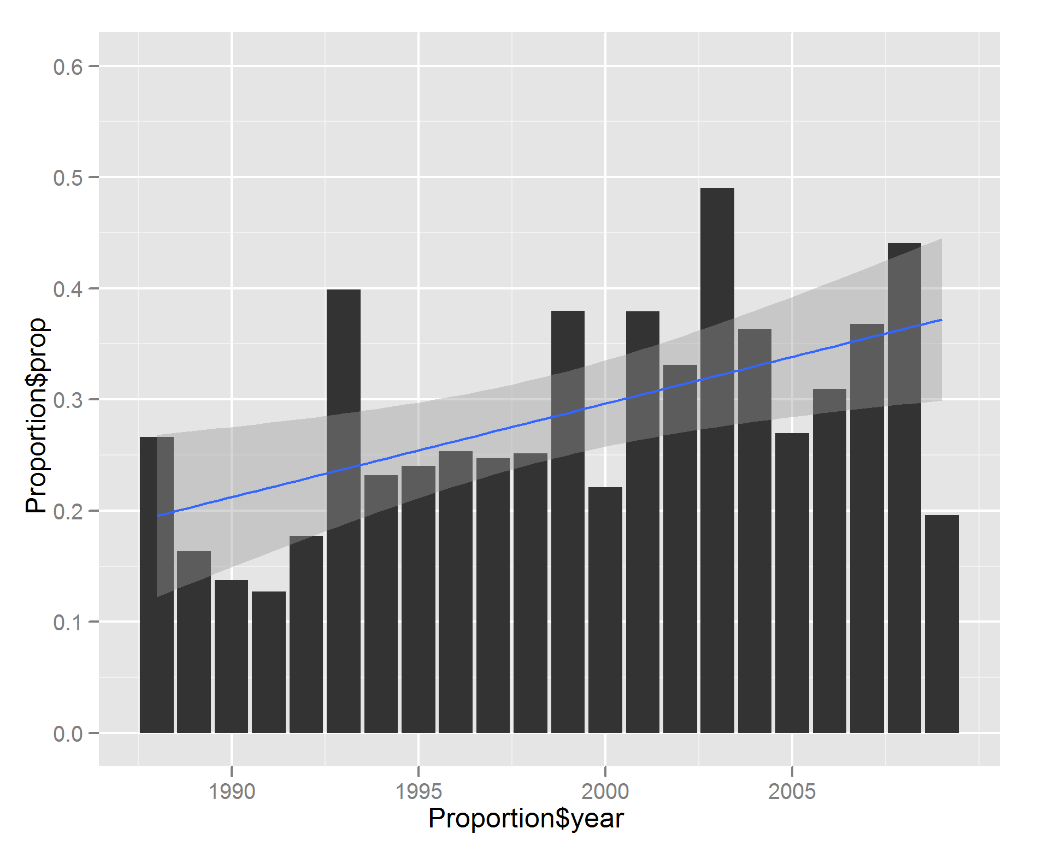

**Figure 1: Percentage of Low- and High-Volume Hospital Management over Time (by Year)**

In order to investigate the impact of surgical volume on short-term outcomes, we separated hospitals into centers that perform relatively higher numbers of sinonasal cancer surgery cases (greater than 5 cases per year) and centers that performed relatively few sinonasal cancer surgery cases (less than 5 cases per year). We identified 32 hospitals which averaged more than 5 cases per year and accounted for 28% of all sinonasal surgery cases. These hospitals were more frequently represented in high-risk cases, accounting for 32.4% of cases requiring neck dissection, 44.9% of cases with orbital involvement, and 45.7% of cases with skull base involvement, despite comprising only 3.6% of all hospitals that performed sinonasal cancer surgery (Table 2). High-volume centers tended to be teaching hospitals (P > 0.001), and large, urban hospitals were also more represented (Table 3).

THESE LAST FEW SENTENCES BEG THE QUESTION – WHAT HAPPENS WHEN A HIGH RISK CASE IS DONE AT A LOW VOLUME HOSPITAL? (ADDED IN PARAGRAPH AFTER AGGREGATE COMPLICATIONS)

|  |  |  |  |  |  |  |
| --- | --- | --- | --- | --- | --- | --- |
| **Table 2.** Number of Hospitals, Sinonasal Cancer Surgeries Stratified by Hospital Caseload | | | | | |  |
|  | **1988 to 2009** | | | | |  |
|  | **Hospitals, n (%)** | **Cases (%)** | **Cases with Neck Dissection (%)** | **Cases with Orbital Involvement (%)** | **Cases with  Skull Base Involvement (%)** | **Complicated Cases,  Total (%)** |
| High Volume Hospitals (>5 Cases/Year) | 32 (3.6) | 1061 (28.5) | 79 (32.4) | 106 (44.6) | 128 (43.1) | 277 (38.7) |
| Low Volume Hospitals (<5 Cases/Year) | 847 (96.4) | 2789 (71.5) | 165 (67.6) | 130 (53.4) | 169 (56.9) | 418 (61.3) |
| **Total** | **879 (100)** | **3,850 (100)** | **244 (100)** | **236 (100)** | **297 (100)** | **715 (100)** |
|  |  |  |  |  |  |  |

|  |  |  |  |  |  |  |  |  |
| --- | --- | --- | --- | --- | --- | --- | --- | --- |
| **Table 3.** Hospital Characteristics of Admissions for Sinonasal Cancer Surgery | | | | | | | | |
|  | |  | **High Volume Centers  (>5 Cases/Year)**a | | | **Low Volume Centers (>5 Cases/Year)**a | |  |
| Hospital size, n (%)b | Small | | 3 (10.0) | | | 113 (13.6) | | |
| Medium | | 5 (16.7) | | | 254 (30.7) | | |
|  | Large | | 22 (73.3) | | | 461 (55.7) | | |
|  |  | |  |  | | |  | |  |
| Hospital type, n (%) | Teaching | | 27 (90.0) | | | 346 (41.8) | | |
| Non-teaching | | 3 (10.0) | | | 482 (58.2) | | |
|  |  | |  |  | | |  | |  |
| Hospital location, n (%) | Urban | | 29 (96.7) | | | 707 (85.4) | | |
| Non-urban | | 1 (3.3) | | | 121 (14.6) | | |
|  |  | |  |  | |  | | |  |
| Complex Cases,  n (%)c | Neck Dissection | | 79 (7.4) | | | 165 (5.9) | | |  |
| Orbital Involvement | | 106 (10.0) | | | 130 (4.7) | | |  |
| Skull Base Involvement | | 128 (12.0) | | | 169 (6.1) | | |  |
|  | |  |  |  | |  | | |  |
| **Total, n (%)** | |  | **32 (100.0)** | | **847 (100.0)** | | |  |
| Data are cumulative, 1988-2009. aHospital characteristics were not found for 2 high volume hospitals and 19 low volume hospitals.  bHospital size classification is dependent on number of beds and hospital type. For example, for urban, teaching hospitals, “small” signifies < 300 beds and “large” signifies > 500 beds. cPercentage obtained from total number of cases by each subset | | | | | | | | |

Less than 1% of hospitalizations resulted in short-term mortality and 36.9% of patients had complications ranging from neuropathies and visual impairment to infections and cardiopulmonary arrest (Table 4). Cardiopulmonary complications were the most common class of complications, representing about half of all complications, while visual defects and neuropathies directly resulting from the surgery was present in a minority of cases. There was a statistically significant difference in overall complication rate between high-volume and low-volume centers (Chi-squared test, p = 0.018), with higher rates of cardiopulmonary complications (p = 0.024) and peri-operative electrolyte abnormalities (p = 0.002) seen at high-volume centers. There was no difference in mortality between high-volume and low-volume centers (p = 0.122).

There were 715 cases that either included neck dissection, had orbital or maxillary sinus involvement, or had skull base involvement, of which 277 were performed at high-volume centers and 418 were performed at low-volume centers. Two cases had surgeries that met all three criteria and 59 patients had surgeries that met two of the three criteria. These complicated cases had a mean length of stay of 9.4 days (vs. 6.2 days for uncomplicated cases, p < 0.0001) had higher rates of morbidity and mortality. Among these high-risk surgeries, 29.4% resulted in the listed complications, compared to 23.2% of cases without such extra-sinonasal intervention (p < 0.0001). For complicated cases, there was no observed difference in overall complication rate or mortality between high-volume and low-volume centers.

|  |  |  |  |  |  |  |  |
| --- | --- | --- | --- | --- | --- | --- | --- |
| **Table 4.** Complications of Sinonasal Cancer Surgery | | | | | | | |
|  | **Total** | **High-Volume Centers** | | **Low-Volume Centers** | | | **Pa** |
| Deaths, n (%) | 30 (0.8) | 4 (0.4) | | 26 (0.9) | | 0.122 | |
|  |  |  | |  |  | | |
| Infectious, n (%) |  |  | |  | | 0.119 | |
| Surgical Site Infection | 70 (1.8) | 14 (1.3) | | 56 (2.0) | |  | |
| Urinary Tract Infections (UTIs) | 71 (1.8) | 16 (1.5) | | 55 (2.0) | |  | |
| Pneumonia | 30 (0.8) | 9 (0.8) | | 21 (0.8) | |  | |
| Unspecified Postop Infection | 17 (0.4) | 3 (0.2) | | 14 (0.5) | |  | |
|  |  |  | |  | |  | |
| Cardiopulmonary, n (%) |  |  | |  | | 0.024b | |
| Stroke | 16 ((0.4) | 8 (0.8) | | 8 (0.3) | |
| Cardiac Arrest | 8 (0.2) | 1 (0.1) | | 7 (0.3) | |  | |
| Other Cardiac Complications | 456 (11.8) | 127 (12.0) | | 329 (11.8) | |  | |
| Pulmonary Complications | 239 (6.2) | 87 (8.2) | | 152 (5.4) | |  | |
|  |  |  | |  | |  | |
| Other, n (%) |  |  | |  | |  | |
| Neuropathies  Visual Impairment | 51 (1.3) | 13 (1.2) | | 38 (1.4) | | 0.861 | |
| 76 (2.0) | 20 (1.9) | | 56 (2.0) | | 0.908 | |
| Hemorrhage | 46 (1.2) | 12 (1.1) | | 34 (1.2) | | 0.953 | |
| Electrolyte Abnormalities | 312 (8.1) | 110 (10.4) | | 202 (7.2) | | 0.002b | |
|  |  |  |  | | |  | |
| **Total Complications** | **1392 (36.9)** | 424 (40.0) | | 998 (35.8) | | 0.018b | |
| aChi Square Test Comparing High-Volume and Low-Volume Centers. b P < 0.05 | | | | | | | |

Over the time period of analysis, a greater proportion of cases were done at high volume centers (Figure 1). At the same time, a greater number of cases required neck dissection or had orbital sinus, maxillary sinus, or skull base involvement (Figure 2). There was a decrease in mortality over time (p < 0.001), however concomitantly there was an increase in the complicate rate (Figure 3). The make-up and distribution of the types of complications has not changed during the time period of analysis (Supplemental Figure D).

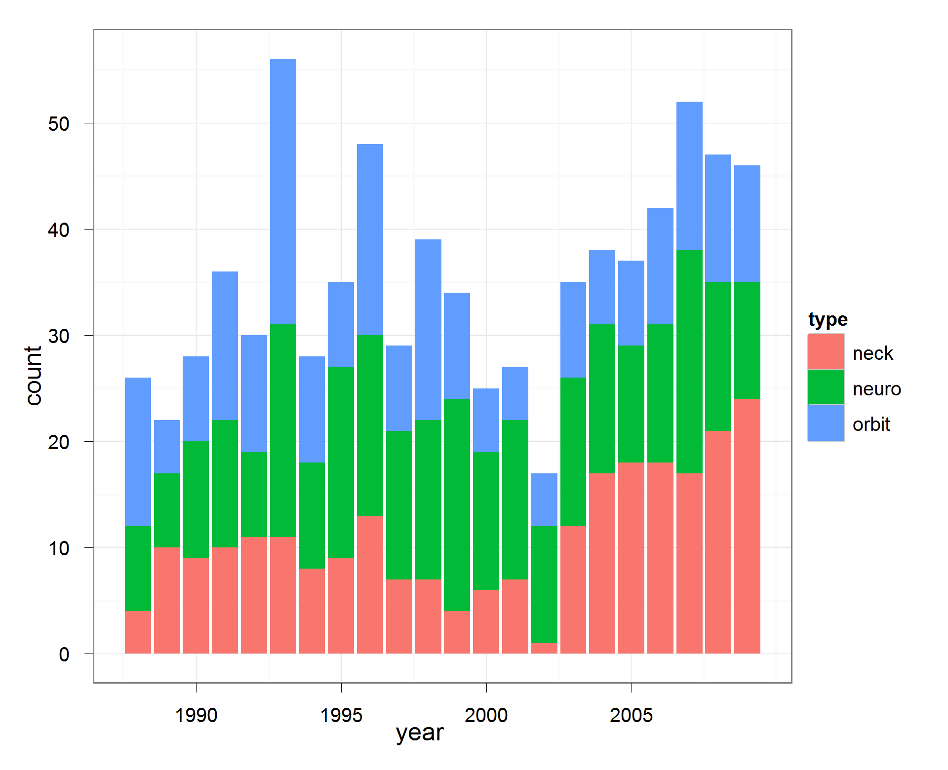

**Figure 2: Rate of High-Risk Surgeries over Time (by Year)**

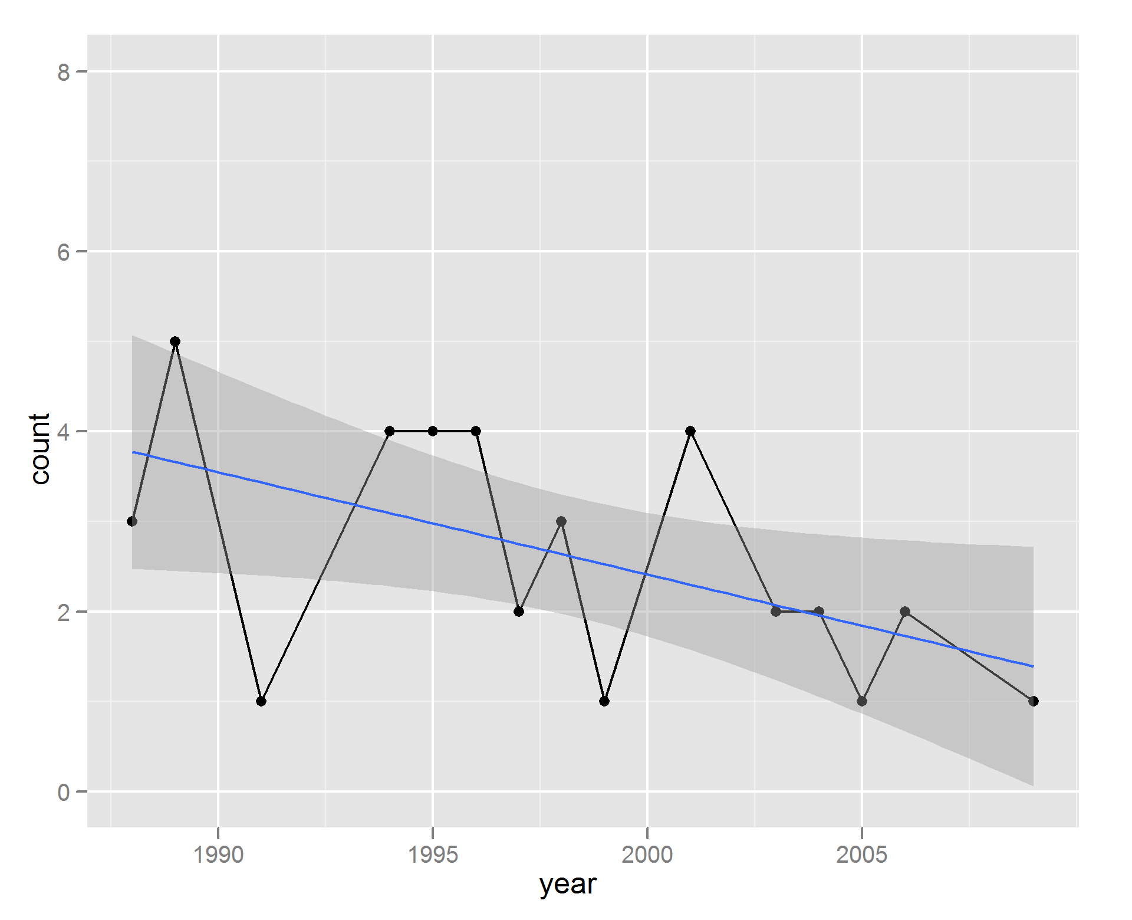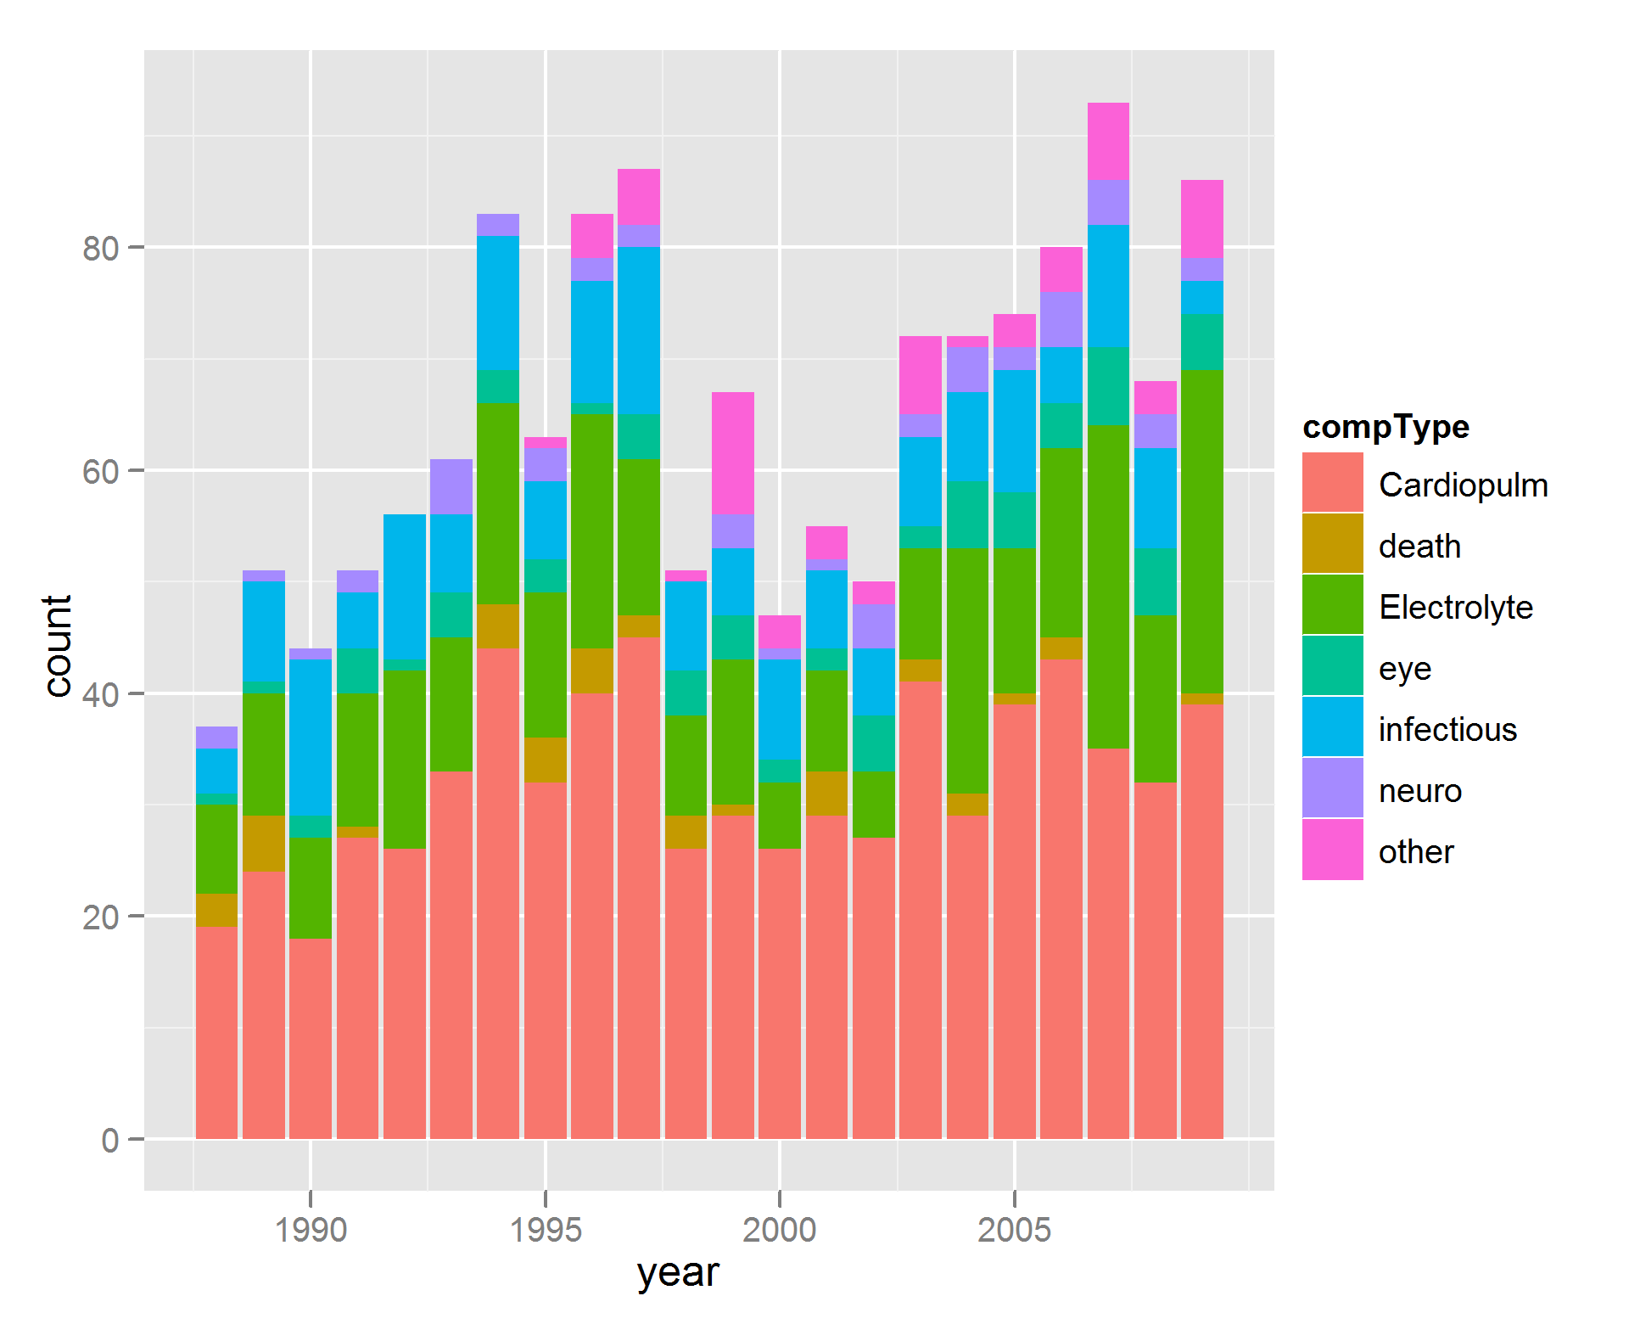

**Figure 3: Rate of Surgery-Related Morbidity and Mortality over Time (by Year)**

**Discussion**

Sinonasal cancers are a highly heterogeneous collection of morbid neoplasms often initially treated with surgery and adjuvant radiotherapy. Initially, these cancers can be clinically silent or mimic benign disease such as sinusitis or upper respiratory infections, as evidenced by a relatively high proportion of locally advanced extent at presentation. Our findings are consistent with population based data from SEER, showing a male predominant patient population mostly between 50 – 70 years of age that has not significantly changed in incidence over the last twenty years [9]. Our data did not show significant changes over time in patient race or insurance status.

The staging of sinonasal cancer has changed significantly over the last twenty years. Institutional systems for staging nasal cavity cancer were developed as early as 1988 [3] while maxillary cancer staging has been formalized by the American Joint Committee on Cancer since the 3rd edition in 1988 [19]. The AJCC 6th edition, published in 2003, further subcategorized locally advanced disease in the maxillary sinus into resectable and unresectable disease with subsequently shown survival differences [18,19]. Most case series were retrospectively staged based on the most frequently used staging system of that time [1, 3, 20]. This study does not depend on the staging of sinonasal cancer, rather extrapolating severity based on the need for advanced surgical intervention.

This study confirms the prevalence of advanced initial presentation, shown by the fact that 20.2% of cases in this database required surgery with neck dissection, had orbital or maxillary sinus involvement, or had skull base involvement. In this study, we report that the number of complex cases has only increased over time, with an especially marked increase in the number of cases with neck dissection (Supplemental Figure E).Previous case series have also shown between 39%-95% of cases present initially with advanced disease (Stage III or IV)[1,8]. There does not appear to be a trend over time for lower stage at initial presentation, as evidenced by even recent case series having high proportion of advanced disease (74% between 1995 – 2004 in Denmark[4]).

Advances in surgical management of sinonasal cancer could explain the higher rates of referral over time to high-volume, experienced centers. Previous studies have shown decreased morbidity, decreased mortality, and deceased length of stays at high-volume centers for the surgical management of a variety of head and neck cancers [10, 11, 12]. High volume surgeons, more commonly found at high volume centers, have also been found to have decreased perioperative complications, improved long term survival in cancer, and reduced hospital costs [13 – 16]. These effects were especially seen in complicated cases [16]. The increased referral over time to high-volume, experienced centers could be explained by the increased incidence of complex sinonasal cases over time. Particularly in cases with skull base involvement, it could be advantageous to have surgery at a high-volume center with an integrated approach with neurosurgical support. Although there has been an increase in the number of complex cases performed, there has been a decrease in perioperative mortality for sinonasal cancer surgeries. This could suggest improved surgical technique and post-operative management as more aggressive, larger cases are undertaken without an increase in mortality. Given the poor local control and late presentation of sinonasal cancers, increasingly bigger cases can be suggested by the increase in overall morbidity over time. The incidence of infectious complications has gone down over time, while there in has been an increase in the number of electrolyte abnormalities and cardiopulmonary complications.

Even though high-volume institutions provide care for more high-risk cases, but there was no difference in the mortality rate between high- and low-volume centers. There was no difference in the incidence infectious complications or surgical complications (neuropathies, visual disturbances, or hemorrhage). High-volume institutions had a higher rate of cardiopulmonary complications and electrolyte complications, suggesting that perhaps larger surgeries were attempted which required more aggressive volume resuscitation. Increases in incidence of these two categories of complications also leads to an increased overall complication rate at high volume hospitals.

One limitation of this study is that the National Inpatient Sample does not keep track of long-term outcomes from these hospitalizations. While we were able to show there is little perioperative mortality (0.8%), we were unable to examine long-term survival or complications. Further investigation would be necessary to compare the efficacy of various treatment options.

[1] MDACC <http://www.ncbi.nlm.nih.gov/pubmed?term=18164845> n = 62

[2] Barnes L, Tse LLY, Hunt JL, et al. Tumours of the nasal cavity and paranasal sinuses: Introduction. In: Pathology and Genetics of Head and Neck Tumours, Barnes L, Eveson JW, Reichart P, Sidransky D. (Eds), IARC, Lyon 2005. p.9.

[3] FLORIDA <http://www.ncbi.nlm.nih.gov/pubmed/3335447/> n = 48

[4] DENMARK <http://www.ncbi.nlm.nih.gov/pubmed?term=20001493> n = 242

[5] UCLA <http://www.ncbi.nlm.nih.gov/pubmed/11753979>

[6] WASHU <http://www.ncbi.nlm.nih.gov/pubmed/2846481> n = 62

[7] Earlier Denmark <http://www.ncbi.nlm.nih.gov/pubmed/11321654> n = 315

[8] West Africa <http://www.ncbi.nlm.nih.gov/pmc/articles/PMC2575924/> n = 82

[9] <http://onlinelibrary.wiley.com/doi/10.1002/hed.21830/full>

[10] Oropharyngeal <https://vpn.ucsf.edu/pubmed/,DanaInfo=www.ncbi.nlm.nih.gov+22241647>

[11] Laryngeal https://vpn.ucsf.edu/pubmed/,DanaInfo=www.ncbi.nlm.nih.gov+22052419

[12] Oropharyngeal https://vpn.ucsf.edu/pubmed/,DanaInfo=www.ncbi.nlm.nih.gov+21433017

[13] <https://vpn.ucsf.edu/pubmed/,DanaInfo=www.ncbi.nlm.nih.gov+14645640>

[14] <https://vpn.ucsf.edu/pubmed/,DanaInfo=www.ncbi.nlm.nih.gov+17457171>

[15] <https://vpn.ucsf.edu/pubmed/,DanaInfo=www.ncbi.nlm.nih.gov+12860752>

[16] https://vpn.ucsf.edu/pubmed/,DanaInfo=www.ncbi.nlm.nih.gov+18600379

[17] http://www.ncbi.nlm.nih.gov/pubmed/17309980

[18] <http://archotol.jamanetwork.com/article.aspx?articleid=484651>

[19] <http://www.cancerstaging.org/products/pasteditions.html>

[20] http://www.ncbi.nlm.nih.gov/pubmed/11753979

[21]<http://onlinelibrary.wiley.com/doi/10.1002/lary.22447/full>